

**Table of Contents**

**Audit Manager**

1 How to enable EPMJOB Delete event 3

2 Custom log extension example 9

3 How to enable Item Revision Delete event 13

4 Item Revision delete audit Report. 14

# How to enable EPMJOB Delete event

1. Event Type:

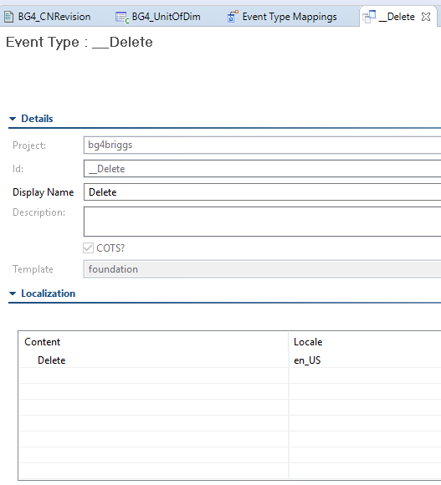

1. Audit Definitions:

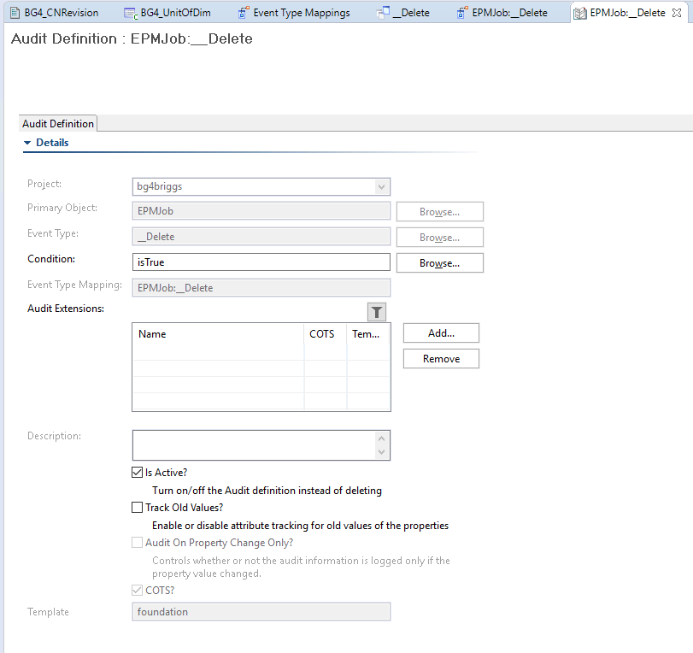

1. Event Type Mapping:

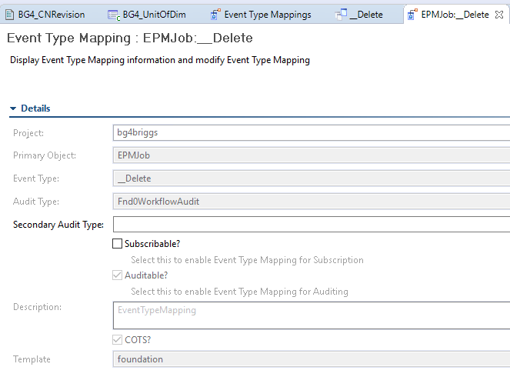

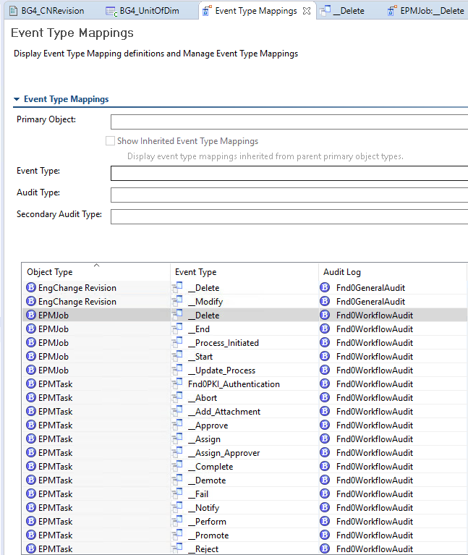

**Extract EPMJob delete report/log file.**

1.Create custom query as shown in below image.

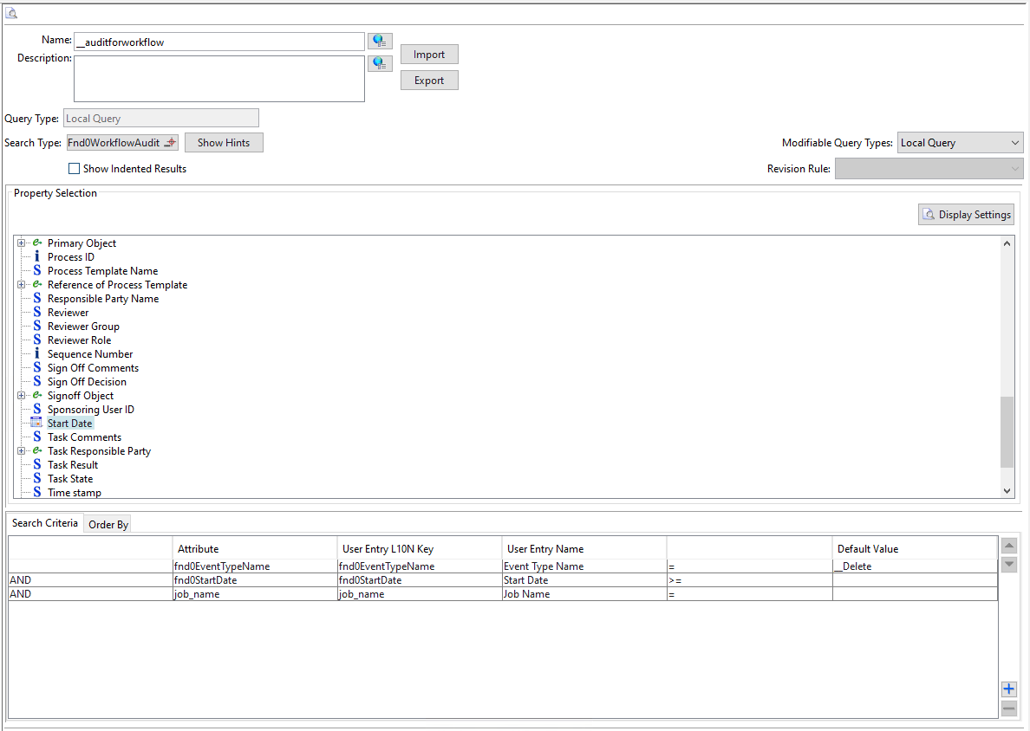

2.Open the custom query to execute in RAC.

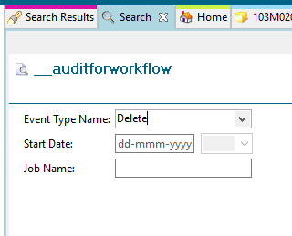

3.Enter the JOB name to find all EPMJob delete report.

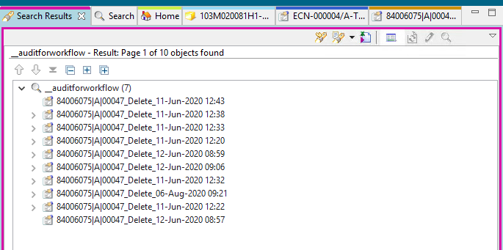

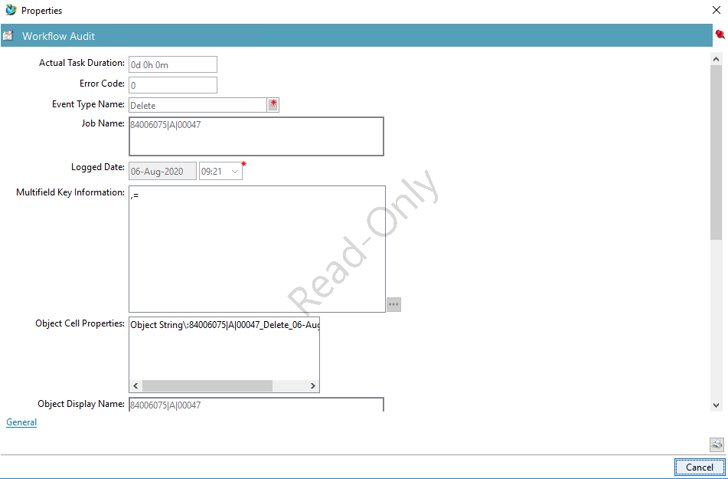

# Custom log extension example

In this example, a log extension named **BG4_CustomAuditLog** is attached to the **EPMTask:_Delete:isTrue** audit definition object. You can create log extensions, using Business Modeler IDE.

1. In Business Modeler IDE, create a template project if you have not already created one.
2. Define the **BG4_CustomAuditLog** extension.
   1. [Create a library](https://docs.sw.siemens.com/en-US/product/282219420/doc/PL20200109161503476.itk/html/add_a_new_library) named **BG4_BRIGGS**.
   2. Expand the project and the **Rules**→**Extensions** folders.
   3. Right-click the **Extensions** folder and choose **New Extension Definition**.

The New Extension Definition wizard runs.

* 1. Perform the following in the **Extension** dialog box:
     1. In the **Name** box, type **BG4_CustomAuditLog**.
     2. In the **Language** box, select **CPlusPlus**.
     3. In the **Library** box, select **BG4_BRIGGS**.
     4. Click **Add** to the right of the **Availability** table and perform the following in the **Extension availability** dialog box:
        1. In the **Business Object Name** box, select **Fnd0AuditDefinition**.
        2. In the **Operation Name** box, select **fnd0writeAuditLog**.
        3. In the **Extension Point** box, select **PostAction**.
        4. Click **Finish** in the **Extension availability** dialog box

1. Attach the **BG4_CustomAuditLog** extension to the **EPMTask:_Delete:isTrue** audit definition object.
   1. From the **Extensions** view, open **Audit Manager**→**Audit Definitions**. Right-click the **EPMTask:_Delete:isTrue** audit definition and choose **Open**.

The **Audit Definition: EPMTask:_Delete:isTrue** view is displayed.

* 1. Click **Add** to the right of the **Audit Extensions** table and select the **BG4_CustomAuditLog** extension from the **Find an Audit Extension** dialog box.
  2. To save the changes to the data model, choose **BMIDE**→**Save Data Model**.

1. Implement the **BG4_CustomAuditLog** extension.
   1. Right-click the **BG4_CustomAuditLog** extension and choose **Generate extension code**.

The extension boilerplate code is generated into a **BG4_CustomAuditLog.cxx** C++ file and a **BG4_CustomAuditLog.hxx** header file. To see these files, open the project in the **Navigator** view and browse to the **src\server\BG4_BRIGGS** directory.

Note:

You might need to right-click in the view and choose **Refresh** to see the files that were generated.

* 1. Open the **BG4_CustomAuditLog.cxx** file in a C/C++ editor and add your custom business logic.

Generated code has method signature as **int BG4_CustomAuditLog ( METHOD_message_t *msg, va_list args )**

Replace the method signature as below in **BG4_CustomAuditLog.cxx** and **BG4_CustomAuditLog.hxx**

int BG4_CustomAuditLog  
( tag_t  /*targetObjTag*/,  
int /*secondaryObjectCount*/,  
tag_t* /*secondaryObjectTags*/,  
char** /*secondaryQualifiers*/,  
Char* /*eventType*/,  
int paramCount,  
char** paramNames,  
char** paramValues,  
int /*errorCode*/,  
const char* /*errorMessage*/,  
tag_t primaryAuditBOTag )

The following is a sample file:

int BG4_CustomAuditLog(tag_t targetObjTag,

int secondaryObjectCount,

tag_t* secondaryObjectTags,

char** secondaryQualifiers,

char* eventType,

int paramCount,

char** paramNames,

char** paramValues,

int /*errorCode*/,

const char* /*errorMessage*/,

tag_t primaryAuditBOTag)

{

TC_write_syslog(" Entering BG4_CustomAuditLog\n");

int ifail = ITK_ok;

//tag_t job_tag = NULLTAG;

char* signoff = NULL;

tag_t signoffTag = NULLTAG;

tag_t auditClassId = NULLTAG;

tag_t signoffClassId = NULLTAG;

char* audit_class_name = NULL;

char* signoff_class_name = NULL;

logical isProp = false;

char* propVal = 0;

char* targetObjClassName = NULL;

tag_t auditClassId1 = NULLTAG;

TC_write_syslog(" paramCount : %d\n", paramCount);

TC_write_syslog(" Secondary Object count : %d\n", secondaryObjectCount);

if (paramCount == 0)

{

//return ITK_ok;

}

for (int i = 0; i < paramCount; i++)

{

TC_write_syslog(" paramNames : %s\n", paramNames[i]);

if (strcmp(paramNames[i], "signoff") == 0)

{

signoff = paramValues[i];

break;

}

}

char* uid = NULL;

if (targetObjTag!=NULLTAG)

{

ifail = POM_class_of_instance(targetObjTag, &auditClassId1);

ifail = POM_name_of_class(auditClassId1, &targetObjClassName);

TC_write_syslog(" Target Object Class Name : %s\n", targetObjClassName);

ITK_CALL(POM_tag_to_uid(targetObjTag, &uid));

TC_write_syslog(" Target Object UID : %s\n", uid);

tag_t roottask = NULLTAG;

char* taskUI = NULL;

EPM_ask_root_task(targetObjTag,&roottask);

char* objName = NULL;

char* objString = NULL;

AOM_UIF_ask_value(targetObjTag,"object_name",&objName);

TC_write_syslog(" Object Name : %s\n", objName);

AOM_UIF_ask_value(targetObjTag, "object_string", &objString);

TC_write_syslog(" Object String : %s\n", objString);

if (roottask!=NULLTAG)

{

ITK_CALL(POM_tag_to_uid(roottask, &taskUI));

TC_write_syslog(" Root Task Object UID : %s\n", taskUI);

int n_subtasks = 0;

tag_t*subtasks = NULL;

EPM_ask_sub_tasks(roottask, &n_subtasks, &subtasks);

TC_write_syslog(" SubTask(S) Count : %d \n", n_subtasks);

}

else

{

TC_write_syslog("ROOT TASK IS NULL \n");

}

}

if (primaryAuditBOTag != NULLTAG)

{

ifail = POM_class_of_instance(primaryAuditBOTag, &auditClassId);

ifail = POM_name_of_class(auditClassId, &audit_class_name);

TC_write_syslog(" audit_class_name : %s\n", audit_class_name);

ifail = AOM_set_value_string(primaryAuditBOTag, "fnd0Reason", uid);

}

TC_write_syslog(" Exiting BG4_CustomAuditLog\n");

* 1. Open the **BG4_CustomAuditLog.hxx** file and update it with the header information.

1. Build the library (**libBG4_Briggs.dll**file) for the **BG4_CustomAuditLog** extension.
2. (For hot deploy only) Copy the **libBG4_Briggs.dll**file to the *TC_ROOT***\bin** directory.

# How to enable Item Revision Delete event

1. Create custom audit definition.

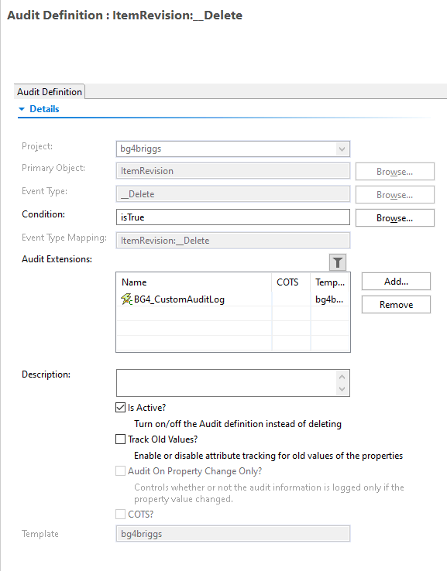

1. OOTB Event type Mapping.

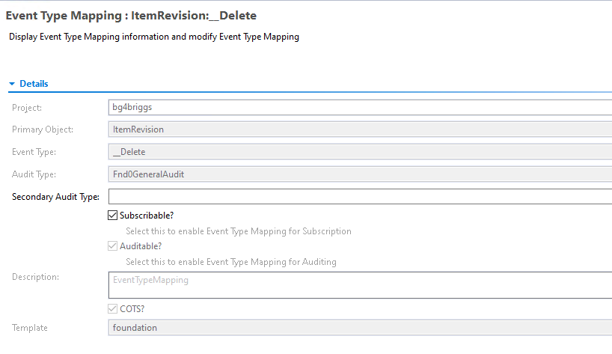

# Item Revision delete audit Report

